School vision and values
At Queensbridge we aim to develop well rounded, confident and responsible individuals who aspire to achieve their full potential. We do this by providing a welcoming, inclusive, safe, and supportive learning environment in which everyone is equal and all achievements are celebrated.

RESPECT
- We are responsible for our actions
- We are empathetic
- We are inclusive
COLLABORATION
- We are able to ask for and give support
- We are articulate
- We are a team
PERSEVERANCE
- We don’t give up
- We celebrate our mistakes
- We are ambitious
POSSIBILITIES
- We are globally aware
- We are forward thinking
- We are curious

Aims
We are committed to meeting our obligations with regards to school attendance by:
• Promoting good attendance and reducing absence, including persistent absence
• Ensuring every child has access to full-time education to which they are entitled
• Acting early to address patterns of absence
We will also support parents/carers to perform their legal duty to ensure their children of compulsory school age attend regularly, and we will promote and support punctuality.
Why Regular Attendance is so important
Learning
Any absence affects the pattern of a child’s schooling and regular absence will seriously affect their learning
Safeguarding
Your child may be at risk of harm if they do not attend school regularly. Safeguarding the interests of each child is everyone’s responsibility and within the context of this school, promoting the welfare and life opportunities for your child encompasses:
• Attendance
• Behaviour Management
• Health and Safety
• Access to the Curriculum
• Anti- bullying
Failing to attend school on a regular basis will be considered a safeguarding matter.

Legislation and guidance
Ensuring your child’s regular attendance at school is your legal responsibility and permitting absence from school without a good reason creates an offence in law and may result in prosecution.
This policy meets the requirements of the school attendance guidance from the Department for Education (DfE), and refers to the DfE’s statutory guidance on school attendance parental responsibility measures.
These documents are drawn from the following legislation setting out the legal powers and duties that govern attendance:
• Part 6 of The Education Act 1996
• Part 3 of The Education Act 2002
• Part 7 of The Education and Inspections Act 2006
• The Education (Pupil Registration) (England) Regulations 2006 (and 2010, 2011, 2013, 2016 amendments)
• The Education (Penalty Notices) (England) (Amendment) Regulations 2013
This policy also refers to the DfE guidance on the school census, which explains the persistent absence threshold.
Attendance of Looked After Children
The school has a designated teacher responsible for overseeing the education of children in public care. This role will include the monitoring of attendance rates which are reported to the Education Attendance Service. Any concerns should be notified as soon as possible to the carer, social worker and School Attendance Officer for vulnerable children.
Change of Address
If a family are moving to a new address, parents/carers must provide school with their new address and contact numbers. If the family are moving overseas, parents/carers must provide travel documents and a forwarding address. Failure to do this will result in a referral to the ‘Children Missing Education’ officer at the Hackney Learning Trust.
Telephone Numbers
There are times when we need to contact parents/carers. You must provide the school with up to date numbers – if you don’t then something important may be missed. We require at least 3 additional contacts over and above the primary parent/carer in case we cannot get through to the primary contact. There will be termly checks on telephone numbers, contacts and addresses throughout the year.
Moving to another school
Parents/carers must notify the school immediately if they are removing their child to start at another school. The parents/carers must provide the name of the new school. If a family are moving to a new address, which requires the child to attend a new school but the child is not yet registered then parents/carers must provide school with their new address. Occasionally children may move away from the school without notifying us. We make every reasonable effort to locate the child and their family. Removal from roll may be backdated if we subsequently receive proof of dates of attendance at the new school. If we are unable to make communication with the family, the child is kept on roll for 20 days and then the Educational Welfare Officer and Children Missing Education Service are notified.
Promoting Regular Attendance
Helping to create a pattern of regular attendance is everybody’s responsibility - parents, children and all members of school staff. To help us all to focus on this we will:
• Report to you how your child is performing in school, what their attendance and punctuality rate is and how this relates to their attainment;
• Celebrate good attendance by displaying individual and class achievements;
• Reward good or improving attendance through class competitions, certificates and outings/events.
Understanding types of Absences
Every half-day absence from school has to be classified by the school (not by the parents/carers), as either AUTHORISED or UNAUTHORISED. This is why information about the cause of any absence is always required, preferably in writing.
Authorised absences are mornings or afternoons away from school for a good reason like illness. Medical/dental/optician appointments should be made outside of school time when possible. The appointment letter should be shown to the school office in advance.
Unauthorised absences are those which the school does not consider reasonable. This includes:
• Parents/carers keeping children off school unnecessarily
• truancy before or during the school day
• absences which have never been properly explained
• children who arrive at school too late to get a mark
• shopping, looking after other children or birthdays
• day trips and holidays in term time
This type of absence can lead to the Hackney Education using sanctions and/or legal proceedings.
Whilst any child may be off school because they are ill, sometimes they can be reluctant to attend school. Any problems with regular attendance are best sorted out between the school, the parents/carers and the child. If a child is reluctant to attend, it is never better to cover up their absence or to give in to pressure to excuse them from attending. This gives the impression that attendance does not matter and usually make things worse.
Persistent Absenteeism (PA):
A child becomes a ‘persistent absentee’ when they miss 10% or more schooling across the school year for whatever reason. Absence at this level is doing considerable damage to any child’s educational prospects and we need parents fullest support and co-operation to tackle this.
We monitor all absence thoroughly. Any case that is seen to have reached the PA mark or is at risk of moving towards that mark is given priority and parents/carers will be informed of this immediately.
PA children are tracked and monitored carefully through our pastoral system and we also combine this with academic mentoring where absence affects attainment.
All PA cases are also automatically made known to the school’s Educational Welfare Officer.
Absence Procedures
If your child is absent you must:
• Contact us as soon as possible on every day of absence;
• Or, you can come into school and report to reception, who will arrange for a member of staff to speak with you.
• If your child is due to have a planned medical procedure/operation, you must notify the school in advance and provide documentary evidence.
If your child is absent we will:
• Telephone or text you on the first day of absence if we have not heard from you;
• Invite you in to discuss the situation with our Attendance Officer and/or Head of School if absences persist;

• Ask you to provide medical evidence, for example, a doctor’s letter or prescription medication if attendance falls below 96%
• Refer the matter to the school’s Educational Welfare Service if attendance moves below 90%.
The School Education Welfare Service (Synergy)
Parents/carers are expected to contact school at an early stage and to work with the staff in resolving any problems together. This is nearly always successful. If difficulties cannot be sorted out in this way, the school may refer the child to the school’s Education Welfare Officer. They will also try to resolve the situation by agreement but, if other ways of trying to improve the child’s attendance have failed and unauthorised absences persist, these Officers can use sanctions such as Penalty Notices, Fines (£60, rising to £120 if not paid within 28 days (Anti-social Behaviour Act 2004) or prosecutions in the Magistrates Court. Full details of the options open to enforce attendance at school are available from the school or Hackney Education.
Alternatively, parents/carers or children may wish to contact the Welfare Officer themselves to ask for help or information. They are independent of the school and will give impartial advice. Their telephone number is available from the school office.
Lateness
A pupil who arrives late:
• Before the register has closed will be marked as late, using the appropriate code
• After the register has closed, will be marked as absent, using the appropriate code
The school must ensure every child is recorded in case of emergency evacuation. Children arriving late for school MUST go directly to the school office to be recorded on the electronic register.
How we Manage Lateness
The school day starts at 8:55 and we expect your child to be in class at that time.
If your child arrives after 8:55 they are late and need to go directly to the school office to be recorded on the electronic register.
Children who arrive after 9 but before 9:10 are coded “L” (late) in the register. Those children who arrive after 9:10 are coded “U” which is an unauthorised absence. 10 sessions of unauthorised absences may result in a Penalty Notice Warning being issued by the Hackney Education. A session is equal to a half day absence.
If your child has a persistent late record you will be asked to meet with the Head of School and/or Educational Welfare Officer to resolve the problem, but you should approach us at any time if you are having problems getting your child to school on time.
Children picked up late after school
Such incidents can cause distress to children who are keen to see their parents/carers at the end of the school day and should be avoided at all cost.
Parents/carers must telephone the school office if they are running late and inform them as to the time of their arrival in school. On arrival, the school office will ask parents/carers to fill in a brief form detailing the reason for late collection.
Children not picked up after school
If you regularly collect your child late from school, your child will be placed in playcentre and you will incur a fee. You will also be asked to attend a meeting with a member of SMT to discuss persistent lateness.
The school will make all reasonable effort to contact parents/carers who fail to collect their child after school. If we are unable to make any contact with you we will contact your emergency contact numbers. If we receive no response from any of your number by 5.15pm we will need to contact the Emergency Duty Team at Social Services who will take over the care of the child.

Term Time absence
The school will only grant a leave of absence to children during term time if they consider there to be ‘exceptional circumstances. A leave of absence is granted at the Head’s discretion. The school considers each application for term-time absence individually, considering the specific facts, circumstances and relevant context behind the request.
Valid reasons for authorised absence include:
• Illness and medical/dental appointments
• Religious observance – where the day is exclusively set apart for religious observance by the religious body to which the child’s family belong. If necessary, the school will seek advice from the family’s religious body to confirm whether the day is set apart
• Traveller pupils travelling for occupational purposes – this covers Roma, English and Welsh Gypsies, Irish and Scottish Travellers, Showmen (fairground people) and Circus people, Bargees (occupational boat dwellers) and New Travellers. Absence may be authorised only when a Traveller family is known to be travelling for occupational purposes and has agreed this with the school but it is not known whether the child is attending educational provision.
Taking leave in term time will affect your child’s schooling as much as any other absence. All applications for leave must be made in advance.
Any period of leave taken without the agreement of the school, will be classed as unauthorised and may attract sanctions such as a Penalty Notice.
If special leave is granted, parents/carers must give a return date and notify the school as soon as possible if this change.
If a child fails to return on the agreed date, the school will refer the case to the Educational Welfare Officer. The child will remain on roll whilst an investigation is carried out. If the child does not return to school the school will then contact the ‘Children Missing Education’ Officer and will liaise regarding the correct common transfer file. If the child is subject to child protection plans social services will be immediately notified.
The Governors will not authorise any leave at times when children are scheduled to take public examinations. Parents/carers will be notified as soon as these dates are known.
If children are on leave without authorisation Hackney Education has the power to issue Fixed Penalty Notices of £60, rising to £120 if not paid within 28 days (Anti-social Behaviour Act 2004).
If parents/carers take children on unauthorised holiday within term time, the absence will be coded G. An instant fine for G codes will be issued on the 3rd day of absence which is back dated to the first day of absence.
Monitoring Attendance and Punctuality
The senior leadership team works closely with class teachers, the school office and the Educational Welfare Officer. School registers are monitored weekly to identify class attendance and punctuality percentages. Individual attendance and punctuality is monitored on a daily basis.
Every week in the assembly, the classes with the best punctuality and attendance for the previous week are given class certificates.
The school office checks the registers weekly for outstanding unauthorised absences and discusses these with the Head of School and the Education Welfare Officer. Only the school may authorise an absence if they are satisfied that a valid reason has been provided by the parent/carer.
After determining whether there are any issues, parents/carers are written to or invited to an Attendance Surgery to discuss how to resolve these issues. This is nearly always successful. If difficulties cannot be sorted out in this way and if other ways of trying to improve the child’s attendance have failed, court proceedings to prosecute parents may be used.

Legal Sanctions
The school or local authority can fine parents for the unauthorised absence of their child from school, where the child is of compulsory school age.
If issued with a fine or penalty notice, each parent/carer must pay £60 within 21 days or £120 within 28 days. The payment must be made directly to the local authority.
Penalty notices can be issued by a headteacher, local authority officer or the police.
The decision on whether or not to issue a penalty notice may consider:
• The number of unauthorised absences occurring within a rolling academic year
• One-off instances of irregular attendance, such as holidays taken in term time without permission
• Where an excluded pupil is found in a public
If the payment has not been made after 28 days, the local authority can decide where to prosecute or withdraw the notice.
What is the Role of the Parent?
Children are expected to attend school regularly, punctually and appropriately prepared for lessons. The target attendance for all children is a minimum 96%.
Parents and carers are responsible for ensuring their children attend school every day and on time.
Any absence must be reported before 8.45am to the school office only in one of the following ways:
• Email to admin@queensbridge.hackney.sch.uk
• Text or Telephone call or voicemail message to 020 8254 1186
• In person at the school office
(Absence notifications must NOT be left with classroom staff to pass on to the office)
If a parent/carer receives a call or message from the school requesting a reason for their child’s absence, where the parent/carer has forgotten to inform the office, they must respond immediately. They must ensure that any changes to their contact information is given to the school office.
Parents/carers should make all non-emergency appointments outside school hours, where possible. If not possible, then their child needs to attend their appointment and attend school for the remainder of the school day. They must not have a whole day of absence from school. Parents/carers are responsible for providing proof of these appointments to the school office when collecting their child early or dropping their child off late due to an appointment.
What is the Role of Class Teachers?
The class teacher will ensure that the register is taken accurately every morning and after lunch. Class registers are legal records and must be treated accordingly. Class teachers will raise issues of attendance and punctuality with parents/carers if these are having a negative impact on the child’s learning.
What is the Role of the School Office?
The school office is the first point of contact for parents/carers in connection with attendance. They have a crucial role in communicating reasons for children’s absence given by parents/carers. They will note any reasons for absence given by phone message, email or in person to them and record these.
The school office is responsible for ensuring all daily registers are complete and for monitoring individual attendance and punctuality on a daily basis, referring any concerns or queries to the Headteacher. They will contact parent/carers by phone shortly after close of registers if no reason for an absence has been provided. The office will monitor the text has been delivered and check parental contact numbers if it has not. If the primary parent/carer cannot be contacted they will work through the other contacts on the system until the matter is resolved.
The office will inform the Headteacher of any unauthorised absences so that these can be followed up.
What is the Role of the Pastoral Manager?
The Pastoral Manager is here to support families and will liaise closely with the senior leadership team and school office with regard to the punctuality of children. The pastoral manager monitors late arrivals in the morning and ensures these are recorded accurately on the school’s electronic system in the school office.
What is the Role of the Senior Leadership Team?
The SLT have day-to-day responsibility for monitoring attendance and punctuality, co-ordinating responses to concerns about attendance and punctuality, and informing relevant agencies, including the parent/carer community, school governors and the school’s Welfare Service (Synergy Education and Welfare Service) about attendance and punctuality issues.
The Head will ensure that families are aware of their responsibilities regarding punctuality and attendance at the point of admission. This will be supported in the signing of the Home School Agreement.
They will ensure that the school meets all legal requirements, sets targets for attendance and publishes attendance figures. The Head has a duty under the Education (Pupil Registration) Regulations 1995 to make a return to Hackney Education where there is a poor pattern of attendance or a child has had an unauthorised absence for a continuous period of more than two weeks. An attendance summary is submitted to governors termly with a full report to the governing body once a year.
What is the Role of the School Governors?
The governors have overall responsibility for monitoring attendance in school and should be familiar with the current legislation and the school’s registration system. They can request reports on attendance and procedures as necessary. They must ensure that the school is working above the government’s benchmark attendance for primary schools.
One governor has particular responsibility for attendance and liaison with the Head of School. The governors are informed of the attendance statistics termly and in an annual report.
What is the Role of the School’s Educational Welfare Officer?
The Educational Welfare Officer meets frequently with the Headteacher. They advise the school and monitor performance in relation to attendance and punctuality. They also take referrals from the school for more focused interventions with particular families.
Intervening with Children who are Causing Concern Because of Punctuality or Attendance
These interventions include home visits, interviews at school, support for families with particular problems which affect attendance and punctuality. Where necessary, appropriate, legal action against families who are not fulfilling their responsibilities under the Education Act will be taken. These include Penalty Notices, Fines (£60, rising to £120 if not paid within 28 days (Anti-social Behaviour Act 2004) or prosecutions in the Magistrates Court.
Under What Circumstances Do We Take a Child Off Roll?
When a child leaves the school to move to another, we will contact the receiving school to confirm the child’s place. We will only take a child off roll when the new school has confirmed that the child has started.
Children of non-statutory age may have their place withdrawn if their attendance continuously falls below the expected level.
Children Missing Education
Where a child has stopped attending and all efforts by the school and the Education Welfare Officer to contact the parents/carers have failed the child is referred to the Children Missing Education department of Hackney Education in line with the Children Missing Education - amendments to Pupil Registration Regulations, Revised Guidance for Schools, September 2017 and subsequently taken off role in line with the Hackney Education’s Deletions from the Attendance Register Guidance and Advice on School Attendance, December 2018.
Not attending in circumstances relating to coronavirus (COVID-19)
School attendance is mandatory for all pupils of compulsory school age and it is a priority to ensure that as many children as possible regularly attend school. Where a child is required to self-isolate or quarantine because of COVID-19 in accordance with relevant legislation or guidance published by PHE or the DHSC they should be recorded as code X (not attending in circumstances related to coronavirus). Where they are unable to attend because they have a confirmed case of COVID-19 they should be recorded as code I (illness). This code is not counted as an absence in the school census.
For pupils abroad, who are facing challenges to return, code X is unlikely to apply. In some specific cases, code Y (unable to attend due to exceptional circumstances) will apply. Further guidance about the use of codes is provided in the school attendance guidance.
https://www.gov.uk/government/publications/school-attendance
Monitoring
This policy will be reviewed as guidance from the local authority or DfE is updated, and as a minimum every year. At every review, the policy will be approved by the full governing body.
Links with other policies
• Child protection and safeguarding policy
• Wellbeing and behaviour policy
• Remote Education Policy

Appendix
The following codes are taken from the DfE’s guidance on school attendance.
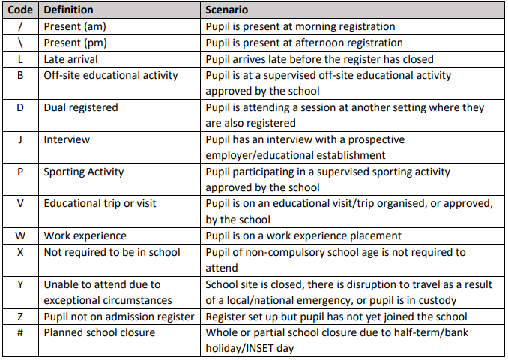

Authorised Absence
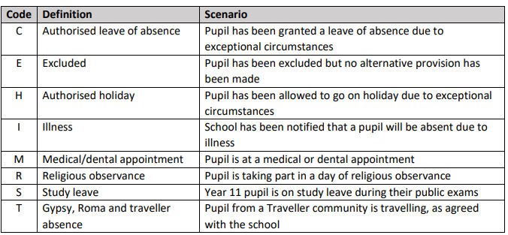
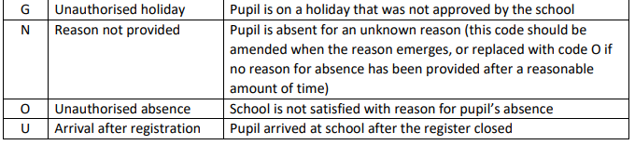

Agreed by Governors Summer 2023
To be reviewed every two years.

