Addition
The expectation for year one and two is children will use number lines and partitioning to add 2 digit numbers. The column method as a formal method of calculation, by the end of year 2 children will begin to use the expanded column method to make them ready for year 3.
National Curriculum Expectations | Calculation Method
Stage 1  Read, write and interpret mathematical statements involving addition.  Represent and use number bonds and related subtraction facts within 20  - add one-digit and two-digit numbers to 20, including zero  - solve one-step problems that involve addition, using concrete objects and pictorial representations, and missing number problems such as 9 = 7+ [ ] . | Number lines  8 + 7 = 15  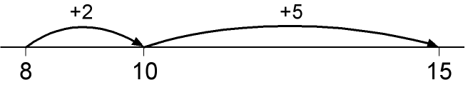
Stage 2  Recall and use addition facts to 20 fluently, derive and use related facts up to 100  Add numbers using concrete objects, pictorial representations, and mentally, including:  - a two-digit number and ones  - a two-digit number and tens  - two two-digit numbers  - adding three one-digit numbers  Show that addition of two numbers can be done in any order (commutative)  Recognise and use the inverse relationship between addition and subtraction and use this to check calculations and solve missing number problems. | Number lines and partition in preparation for column method.  48 + 36 = 84  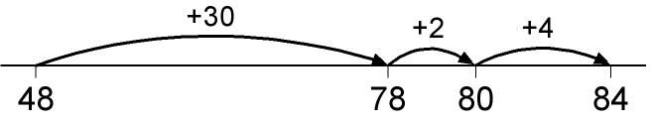  or:  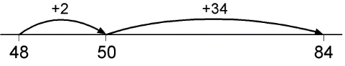  consider alternative below which separates T and U.  H T U  60 7  50 4  10 1 - U  100 10 0 - T  100 20 1

Number Lines
When using a number line, children put the bigger number at the bottom of the number line and count up. The early stages of number lines involve jumping up in ones.
4 + 7 = 11
+1 +1 + 1 +1

7 8 9 10 11

Once children are confident using number lines they will begin to use their number bond knowledge to jump to the next multiple of 10.
4 + 7 = 11
+3 +1 Children use the fact that 7 + 3 = 10
Knowing that 4 is made of 3 + 1 children can make
7 10 11 jumps of 3 and 1.

Partitioning
Children begin to add 2 digit numbers up to 100. They separate the numbers into tens and units as this helps secure place value knowledge which is required when using the column method. They then add the tens and then the units, for example to solve the problem
21 + 18 =
H T U H T U
2 1 + 1 8 =

20 1 10 8

30 + 9 = 39
(20 + 10) (1+8)

Expanded Column Method
The children then use their knowledge of partitioning and place value to add using a written method of calculation. Again, to solve the problem 21 + 18 =
T U
20 1 30 + 9 = 39
10 8
30 9
If the units go above ten we write the whole number
Eg. H T U
90 3 110 + 11 = 121
20 8
10 1
100 10 0

