**Subtraction**

The expectation for year one and two is children will count back on number lines to solve subtraction problems. For numbers with small differences children will count on. Children will be finding the difference between the two numbers.

|  |  |
| --- | --- |
| **National Curriculum Expectations** | **Calculation Method** |
| Stage 1  Use quantities of objects to subtract 2 single digit numbers and count back to find the answer | Children will engage in a variety of counting songs and rhymes and practical activities.  6 – 2 = 4  ‘Take two apples away. How many are left?’  C:\Users\rcondon\AppData\Local\Microsoft\Windows\Temporary Internet Files\Content.IE5\JJLV26JC\red-apple-1365420687hGt[1].jpgC:\Users\rcondon\AppData\Local\Microsoft\Windows\Temporary Internet Files\Content.IE5\JJLV26JC\red-apple-1365420687hGt[1].jpgC:\Users\rcondon\AppData\Local\Microsoft\Windows\Temporary Internet Files\Content.IE5\JJLV26JC\red-apple-1365420687hGt[1].jpgC:\Users\rcondon\AppData\Local\Microsoft\Windows\Temporary Internet Files\Content.IE5\JJLV26JC\red-apple-1365420687hGt[1].jpgC:\Users\rcondon\AppData\Local\Microsoft\Windows\Temporary Internet Files\Content.IE5\JJLV26JC\red-apple-1365420687hGt[1].jpgC:\Users\rcondon\AppData\Local\Microsoft\Windows\Temporary Internet Files\Content.IE5\JJLV26JC\red-apple-1365420687hGt[1].jpg |
| Stage 2  Solve subtraction 1 and 2 digit amounts to 20 using objects and pictures include missing number problems | **Take Away Model**  Children will continue to practise counting back from a given number.  Initially use a number track to count back for subtraction:    9 – 5 = 4 ‘Put your finger on the number nine. Count back five.’  Then progress to a marked number line:    6-4= ‘Put your finger on the number six and count back four.’  NB Ensure children are confident with using a marked number line  **Difference Model**  Counting on to find a small difference:  Introduce complementary addition to find differences (only use for small differences).  The use of models is extremely important here to understand the idea of “difference”.  Count up from the smallest number to the largest to find the difference using resources, e.g. cubes, beads, number tracks/lines: |

To begin with the operation of subtraction children will use physical objects and counting songs such as 5 little ducks. These will be supported with stories, visual images and abstract sums.

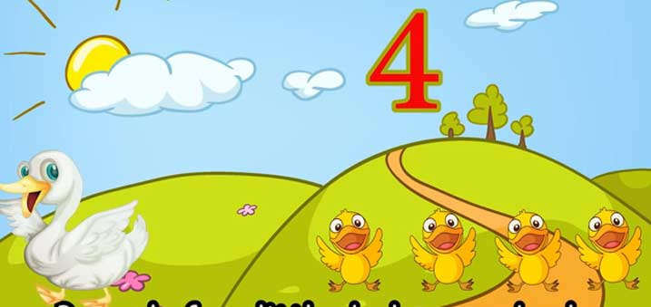

5 – 1 = 4

**Number Lines**

When using a number line, children put the bigger number at the top of the number line and count back. The early stages of number lines involve jumping up in ones.

11 – 4 = 7

-1 -1 - 1 -1

7 8 9 10 11

Once children are confident using number lines they will begin to use their number bond knowledge to make bigger jumps.

11 – 4 = 7

-3 -1 Children use the fact that 7 + 3 = 10

Knowing that 4 is made of 3 + 1 children can make

7 10 11 jumps of 3 and 1.